Photosynthetica
11/6/2008

Problem:
Name of body (in English) in OCLC record: Institute for Experimental Botany of the Czechoslavak Academy of Sciences.
Name of body (in English on piece): Institute of Experimental Botany of the Academy of Sciences of the Czech Republic.

Conclusion: Name change (due to change of heading for parent body embedded in name) → add 710 for new form of name

Pre AACR2 record: OCLC 1762312

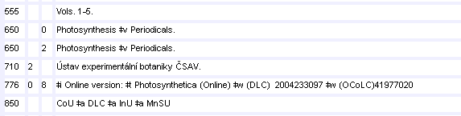
Screen prints
